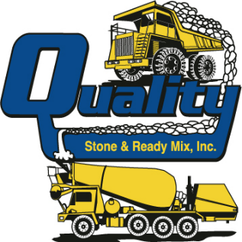

3260 N. Preston Hwy., Shepherdsville, KY 40165
Phone: (502) 955-6962, Fax: (502) 955-6762
Web Site: www.qualitystoneky.com

January 25, 2022
Dear Loyal Customers,

For 68 years my family served the concrete needs of the Louisville area. Since 1965, Quality Stone & Ready Mix, Inc. has provided our customers with top quality concrete at a fair price with courteous, reliable service. I have taken great pride in growing our family business and building relationships with our customers and their families. As you know, after my father retired and then my older two brothers retired, it was my desire to continue our family business. I along with my brother Richard were committed providing the highest quality limestone and ready‐mix construction materials for our customers and maintain a great place for our employees to work and retire.

Since Richard an I purchased the company, we have seen unprecedented times with the pandemic, labor shortages, inflation and increased competition in our region from much larger companies. We have worked extremely hard to continue providing the highest quality construction materials but have been forced to absorb multiple price increases by our suppliers and recently had to pass some of these increases along to you. Coupled with consolidation in the ready‐mix industry, we find ourselves in a difficult environment and have decided to bring the ready-mix part of our business to an end.
The good news is we have partnered with another longtime family business which concentrates entirely on ready‐mix concrete. We are excited to have Ernst Concrete at our quarry. Many of you have worked with Ernst and know they provide high‐quality ready‐mix materials along with quality, reliable customer service.
Beginning January 31st, Quality Stone & Ready Mix will focus solely on our quarry operations and continue to serve your limestone material needs. For your ready-mix concrete needs, we will direct you to Ernst Concrete at 502-241-9441. Orders will be handled through Ernst’s central dispatch but your ready-mix will still ship from this location. You will still see many of the same faces and I will be available during this transition period. I want to personally thank you for your friendship and being a longtime loyal customer. To say this has been a difficult decision is an understatement. Again, we will continue serving your crushed limestone needs and Quality Stone will be here for the next generation.
In the coming days, we will contact you to introduce the Ernst Concrete of KY team. We are committed to making this a seamless transition. We have worked together with Ernst on many projects over the years and know that you will be well served. Thank you for your support during this transition period.

Sincerely,

Jonathan L. Holloway
Quality Stone & Ready Mix, Inc.

